List

Lists are used to **store multiple items in a single variable**.

Lists are one of 4 built-in data types in Python used to store collections of data, the other 3 are [Tuple](https://www.w3schools.com/python/python_tuples.asp), [Set](https://www.w3schools.com/python/python_sets.asp), and [Dictionary](https://www.w3schools.com/python/python_dictionaries.asp), all with different qualities and usage.

**Lists are created using square brackets**:

mylist = ["apple", "banana", "cherry"]

## List Items

List items are ordered, changeable, and allow duplicate values.

List items are indexed, the first item has index [0], the second item has index [1] etc.

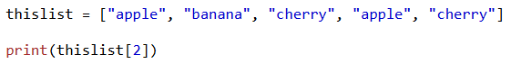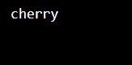

## Ordered

When we say that lists are ordered, it means that the items have a defined order, and that order will not change.

If you add new items to a list, the new items will be placed at the end of the list.

## Changeable

The list is changeable, meaning that we can change, add, and remove items in a list after it has been created.

## Allow Duplicates

Since lists are indexed, **lists can have items with the same value**:

thislist = ["apple", "banana", "cherry", "apple", "cherry"]

## List Length

To determine how many items a list has, use the len() function:

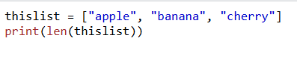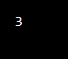

## List Items - Data Types

**List items can be of any data type**:

list1 = ["apple", "banana", "cherry"]  
list2 = [1, 5, 7, 9, 3]  
list3 = [True, False, False]

**A list can contain different data types**:

list1 = ["abc", 34, True, 40, "male"]

## type()

From Python's perspective, lists are defined as objects with the data type 'list':

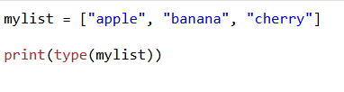

## The list() Constructor

It is also possible to use the list() constructor when creating a new list.

